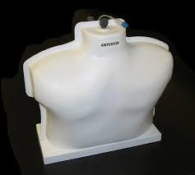

SNMMI PET/CT CTN Oncology Phantom
Instructions for Phantom Analysis Tools

Facility Name: _________________________________________________________
PET SCANNER DATA
Manufacturer: ____________________
Model: ____________________
Year Purchased: ____________________

Phantom Filling Instructions
PRE-FILL LEAK TEST:
  - Fill the body of the phantom through the top fill port with distilled water or, if not available, use tap water. The fill volume of the phantom is close to 10 liters.
  - Dry the outside of the phantom and if possible let it sit in the orientation used for imaging for several minutes.
  - Check the phantom to ensure that there is no leakage of water.
  - EMPTY THE BODY COMPARTMENT BEFORE FILLING IT FOR PHANTOM IMAGING

PREPARATION FOR FILLING AND SCANNING
Equipment needed | - PET Phantom with stand and funnel  - Dose Calibrator  - Timer or clock (Good to within ± 1 minute)
Required Activity | - 5 mCi [185 MBq] F-18 in stable chemical form and which does not stick to plastic (FDG Preferred)
Materials for Phantom Fill | - Approximately 10 liters of water (distilled water preferred if readily available) to fill main body of phantom  - Approximately 1000 mL distilled water for sphere solution.  - Closable container capable of holding 1000 mL solution.  - Syringe (1-3 mL) to fill background (Syringe “1”)  - Syringe (1-3 mL) to create sphere solution (Syringe “2”)  - 30 cc syringe (Syringe “3”) to fill spheres from left sphere port  - 60 cc syringe, if available (Syringe “4”) to fill spheres from right sphere port
Safety Equipment | - Absorbent plastic-backed pads  - Disposable gloves  - Radiation badges  - Lab coat
CAUTION: This phantom requires the use of radioactive materials and should be used only by personnel trained and authorized to perform such work. Ordinary rules and practices should be used for handling radioactive materials and for filling, imaging and emptying of this phantom.

FILLING THE PHANTOM FOR IMAGING
NOTE: The amounts of radioactivity used are specified for imaging approximately 1 hour after assay of the syringe activities. It is recommended to adhere to all filling and imaging times, although fill activities and imaging times may be modified to meet specific situations (clinical trials, site’s own scanner testing procedures…)

Before starting, synchronize your clock with the time on the PET scanner.

PHANTOM DATA
Date Phantom Scanned: ________
Phantom Serial Number: _________

Please enter the phantom fill data both in this table

Table 1: Phantom Fill Data
 | Activity (mCi/MBq) | Target Activity (mCi/MBq) | Time
Syringe 1 (used for filling background) |  | 2.40 mCi/  88.8 MBq | :
Syringe 2 (used for sphere filling solution) |  | 1.00 mCi/  37.0 MBq | :
Syringe 1 residual |  |  | :
Syringe 2 residual |  |  | :
Scan Start Time |  |  | :

Ideally the Phantom fill volume should be measured. If this is not possible, the default volume of 9500 mL can be used. This is most easily and accurately performed by weighing the phantom empty, and then weighing the phantom after the body of the phantom is filled completely.

The recommended fill will result in a sphere to background contrast of 4:1

- GENERAL PREPARATIONS
  - Don lab coat, radiation badges and gloves. Clear a work area to fill the phantom and place absorbent plastic-backed pads on the work area.
  - Prepare the 1000 mL mixing bottle water solution for the spheres by adding precisely 1000 mL of distilled water to a bottle. A closeable bottle is preferred for radiation safety reasons.
  - Ensure that the tubing and spheres in the phantom are empty by placing the phantom flat, ANTERIOR SIDE UP, and then remove the cap from the flexible tubing. Using a large 30-60 cc syringe, remove all liquid by drawing the liquid back into the syringe. Perform this several times. (See appendix to understand why anterior side up is critical and why we need to empty the spheres completely)
  - Remove both large phantom plugs of the main body of the phantom.

- FILLING THE PHANTOM

Preparing the Syringes
  - Using a 1 to 3 cc syringe labeled as Syringe “2” (Spheres).

- Draw up F-18 into a syringe to measure approximately 1.00 mCi (37.0 MBq)
- This must be between 0.97 and 1.03 mCi [35.9 and 38.1 MBq].
- This activity will be used to fill the spheres in the phantom.
- Record activity and assay time in the Table 1 above.

  - Using a 1 to 3 cc syringe labeled as Syringe “1” (Background)

    - Draw up F-18 into a syringe to measure approximately 2.40 mCi (83.25MBq)
    - This must be between 2.37 and 2.43 mCi. [87.7 and 89.9 MBq].
    - This activity will ultimately be added to the phantom background.
    - Record activity and assay time in the table above.
*Imaging should begin within approximately 1 hour*

Filling the Spheres
    - Inject Syringe "2" (Spheres) (1.00 mCi/37 MBq) into the 1000 ml water solution and flush the syringe 2-3 times to ensure that all the activity has been injected into solution.

    - Record the residual radioactivity of Syringe "2" (Spheres) and clock time in Table 1 above.

    - Carefully mix the bottle to ensure uniform distribution of F-18 within the solution.

    - Fill a 30cc syringe with 24-25cc of diluted F-18 from the 1000 mL water solution.

    - Label this as syringe "3"

    - You may use multiple injections from a smaller syringe, provided you are careful to avoid air bubbles in the line.

    - Place the chest phantom horizontally, anterior side up, on a flat counter top as shown in the photograph below. Carefully remove the fill port screws.
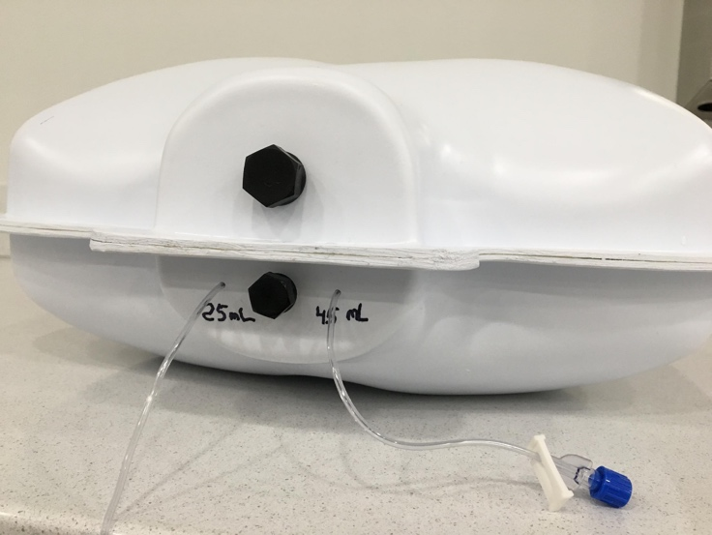
    - See appendix to understand why anterior side up is critical

- Remove the valve cap on the flexible fill ports and attach Syringe “3” to the left flexible fill port. Being careful to not introduce bubbles, inject all 24-25cc’s VERY SLOWLY (about 1cc per 5 seconds); then remove the syringe and replace the valve cap. It should take about 2 minutes to perform this fill.

- Fill a large 60cc syringe with 45-47cc of diluted F-18 from 1000 mL solution.

- Label this as Syringe “4”
● If you do not have a syringe this large, you can do this step with multiple fills from a smaller syringe.

- Remove the valve cap on the flexible tubing on the right. Using Syringe “4” fill this tubing SLOWLY (about 2cc per 5 seconds) with 45-47cc of the F-18 that was diluted into the1,000 mL solution. This should also take about 2 minutes. Then remove the syringe and replace the fill port cap. Using a smaller volume syringe is possible, but care must be taken to avoid introduction of air bubbles.

Filling the Background
  - Turn the phantom upright as shown in the figure below.
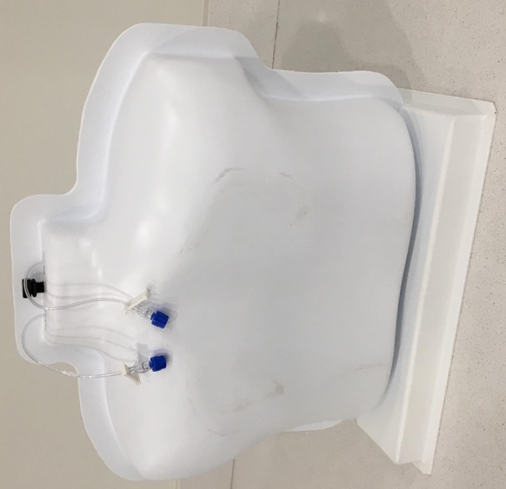
  - Remove the vent port plug (if not already removed) and place the funnel into the main fill port. Add room temperature water (distilled water preferred if available) until filled (approx. 9500 mL).

  - Remove 10cc of water from the main fill port. Inject the contents of Syringe “1” (Background) (2.40 mCi/88.8 MBq) Flush the syringe several times to ensure all activity has been injected into the phantom. Replace the screws/plugs for the Fill Port and Vent Port. Make sure these are tightly screwed in with O-rings to avoid leakage.

  - Record the residual radioactivity and time of assay of Syringe “1” (Background) into Table 1.

  - Hold the phantom firmly in both hands, with the anterior toward you, gently tilt the phantom back and forth for about 15-20 seconds to mix the F-18.
  - Top off the phantom by carefully adding additional water to fill the phantom completely.
- This will likely take more than the 10mL you previously removed.

- Plug the fill holes with the appropriate caps and O-rings.

- Make sure fill and vent ports are not leaking around the O-rings. If they are, tighten them until leak-free.

- IMAGING THE PHANTOM

  - At about 45-50 minutes after measuring the syringes in the dose calibrator, place the phantom on the PET/CT scanner imaging table and immediately perform a scout scan and the attenuation correction CT scan.

  - At approximately 1 hour from the time that Syringe “1” (Background) was measured in the dose calibrator, start the PET scan as described on the following pages.

PROTOCOL | Image the phantom using your standard oncology clinical acquisition protocol.
ALIGNMENT | Align the phantom in the gantry centering the phantom in X, Y and Z using the scanner’s laser alignment system.
AXIAL RANGE | Make sure to cover the entire phantom with the scan (most likely 2-3 bed positions).
CT ATTEN SCAN | Please use your standard clinical CT attenuation scan for reconstruction.

SCAN DATA ENTRY
When prompted by the scanner computer, please enter the data into the scanner patient acquisition record as described below:

Patient Name | CTN Oncology Phantom+facility name  - Example: CTN Oncology Phantom Whoville, MC
MRN | Enter date of scan acquisition as the Medical Record Number: YYYYMMDD
Patient Weight | Enter 63 kg (or 140 lbs)
F-18 Dose | Enter 555 MBq (or 15 mCi)
Enter the injection time | Enter time of F-18 syringe 1 dose calibrator reading

PET RECONSTRUCTIONS
Reconstruct images with and without attenuation correction using your standard clinical reconstruction and label files accordingly.

Reconstruction
Matrix Size:
Iterations:
Subsets:
Gaussian Filter: | mm
Time of Flight?( Y/N) | Yes ☐ No ☐
Point Response Function? (Y/N)  Example: GE SharpIR, Siemens HD-PET, Philips xSharp | Yes ☐ No ☐
Regularized Reconstruction? (Y/N)  Example: GE Q.Clear | Yes ☐ No ☐

PRIMARY IMAGER INFORMATION:
Site Name ____________________________________________________

Print name __________________________________________________

E-Mail Address _____________________________________________

Contact Phone Number ___________________________________

Appendix:

Why does the phantom need to be anterior side up during the filling and emptying of the
spheres?
As mentioned above, the spheres are connected in series by narrow bore tubing. If place anterior
side up, the filling works as previously described, that is, the activity solution fills the spheres from
the bottom until full, and then is pushed out the top as in the figure below.

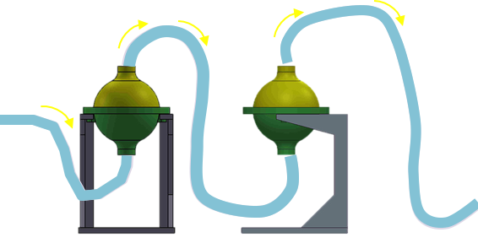

If the phantom is upright, for example, then the spheres will only be filled about half-full before the
solution is pushed out the side – resulting in spheres only being half-filled.

